LARGE SCALE PRODUCTION

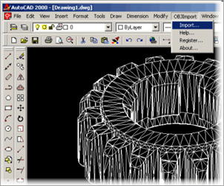
For large scale production the product would be made using CAD software and CNC Software. This would mean each product would be made to an identical standard. The initial set-up costs of buying the software and machinery would be expensive but after that there would be very little investment cost.
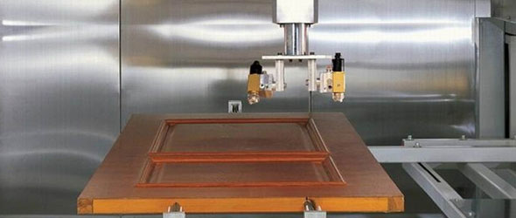
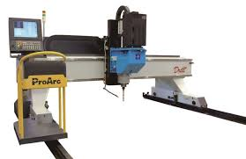
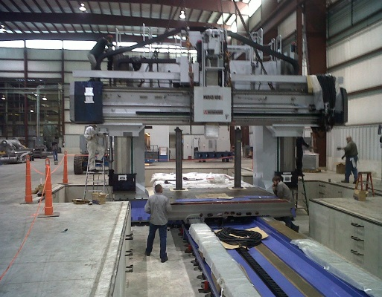
All my drawings could be done using 2D-design but instead of cutting each one out separately they be produced in batches. The drawing on the left shows how all the plywood components of one unit could be made from one section.
The post could be stock bought from a wood supplier or you produced from recycled materials to make the product more environmentally friendly. Drilling machines could be used to add the holes for dowels.
Painting could be done using a machine or by dipping in a paint bath
The main advantage of using CNC routers is that the pieces are accurately cut to a higher standard than hand cutting and there is very little deviation between pieces
This picture shows how all the different 2D-designs would fit onto one page.
Spray painting machine
Drilling Machine
Large Scale CNC machine
2-D Design software

